**Name: Shashwat Tripathi**

**D10A 58**

**Batch C**

**Computer Network Lab**

**Wireshark Installation:**

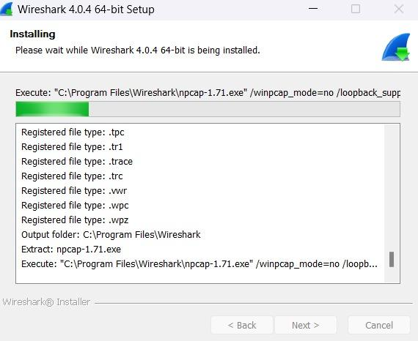

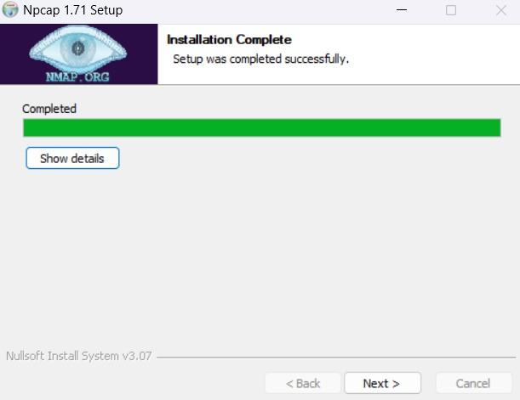

**Wireshark Home Page:**

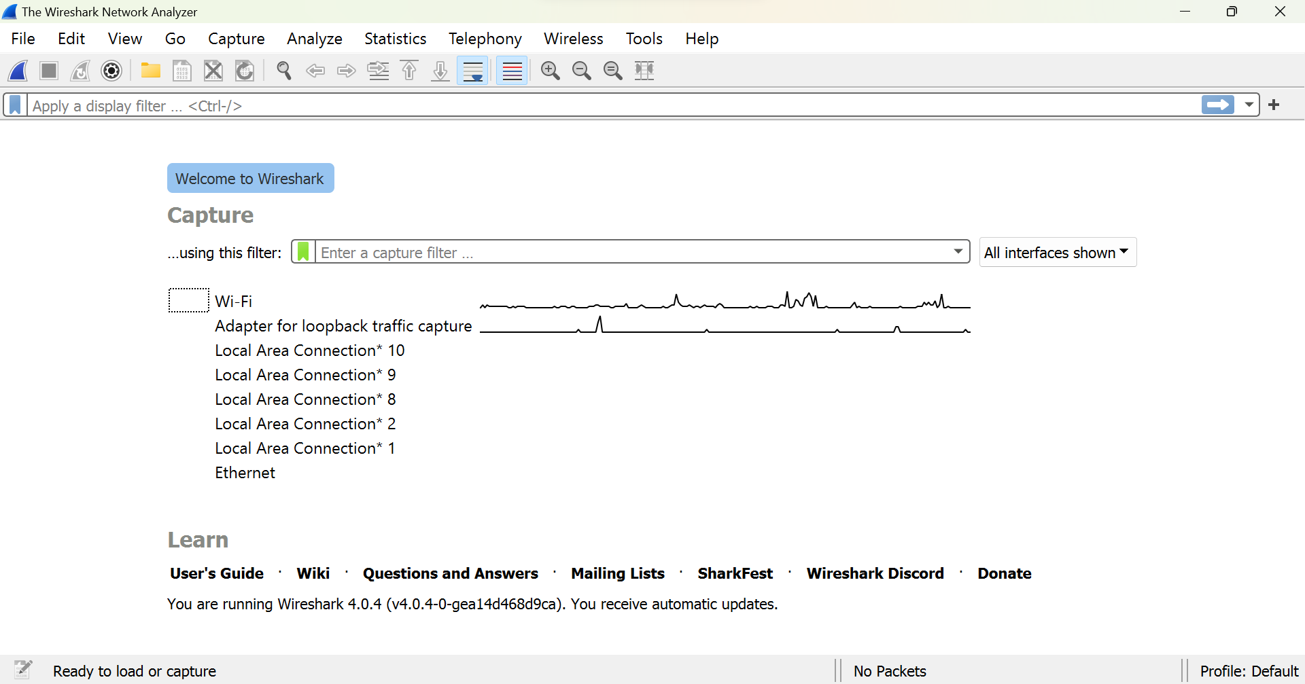

**Wireshark Capturing from Wifi window:**

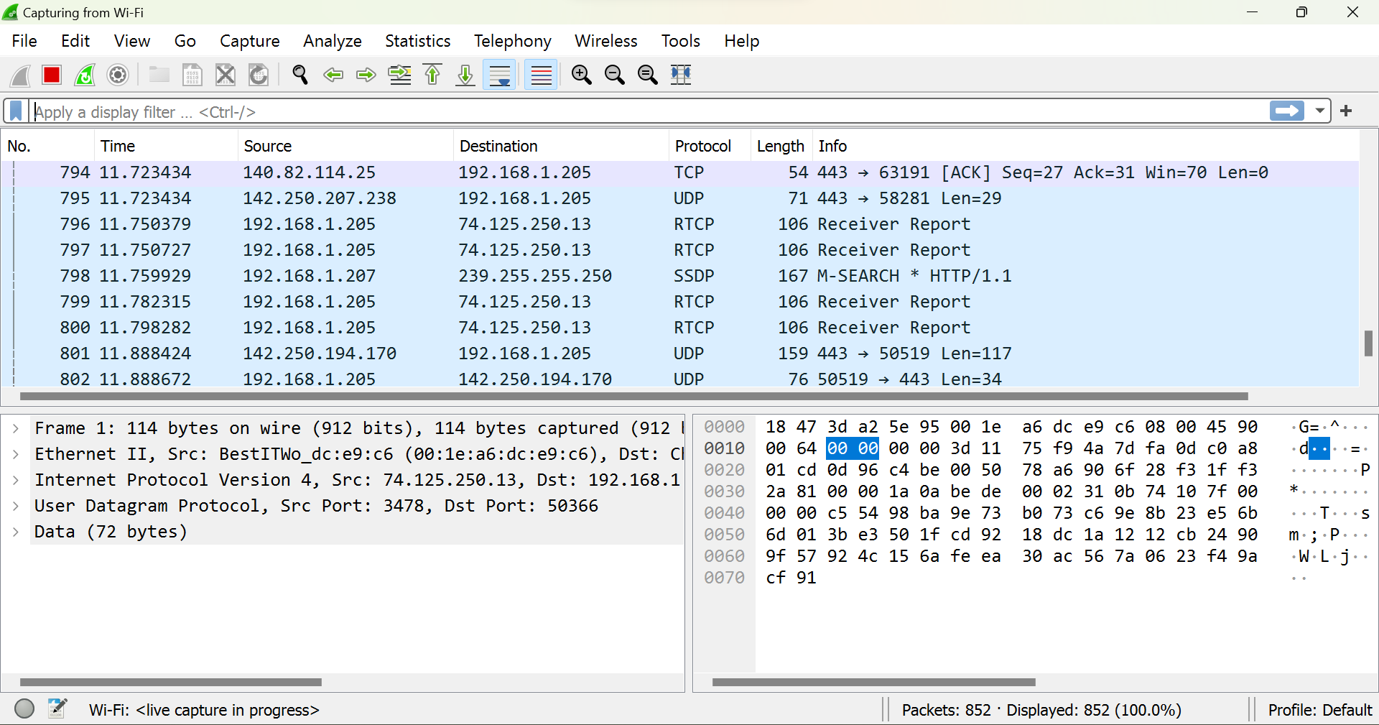

**Wireshark ip.src_host filter applied:**

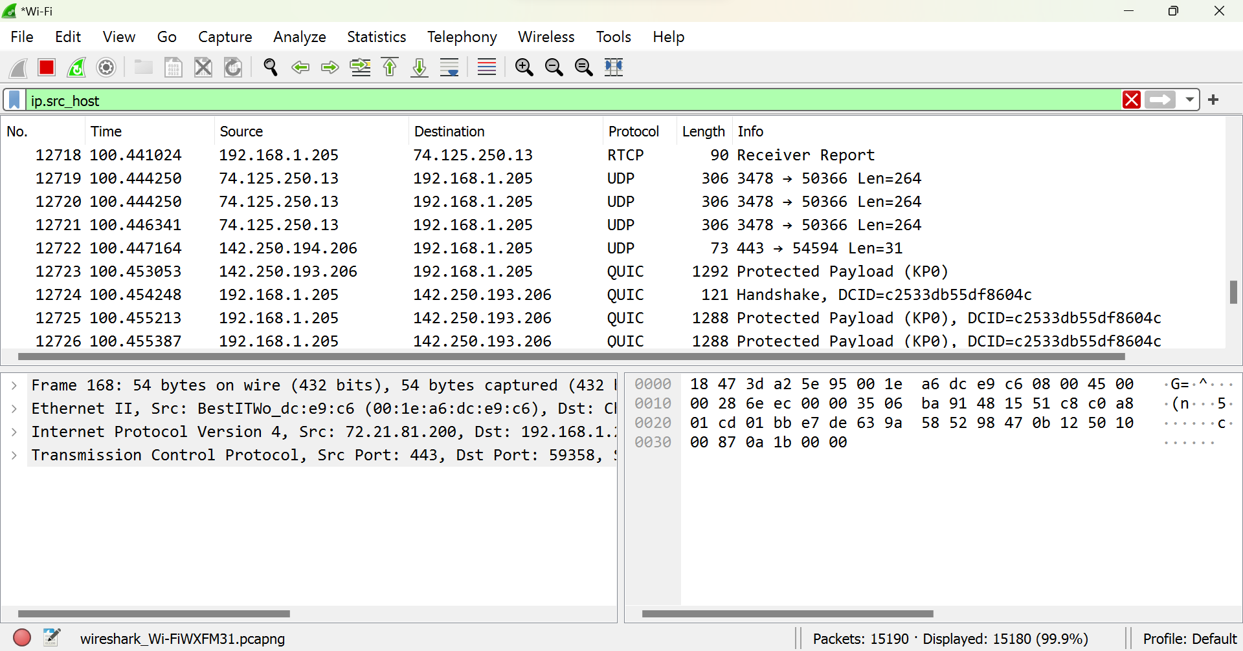

**Wireshark ip.addr filter applied:**

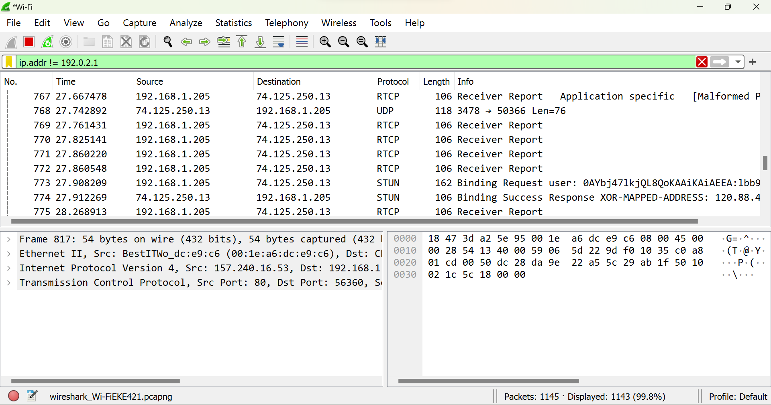

**Wireshark ip.dst filter applied:**

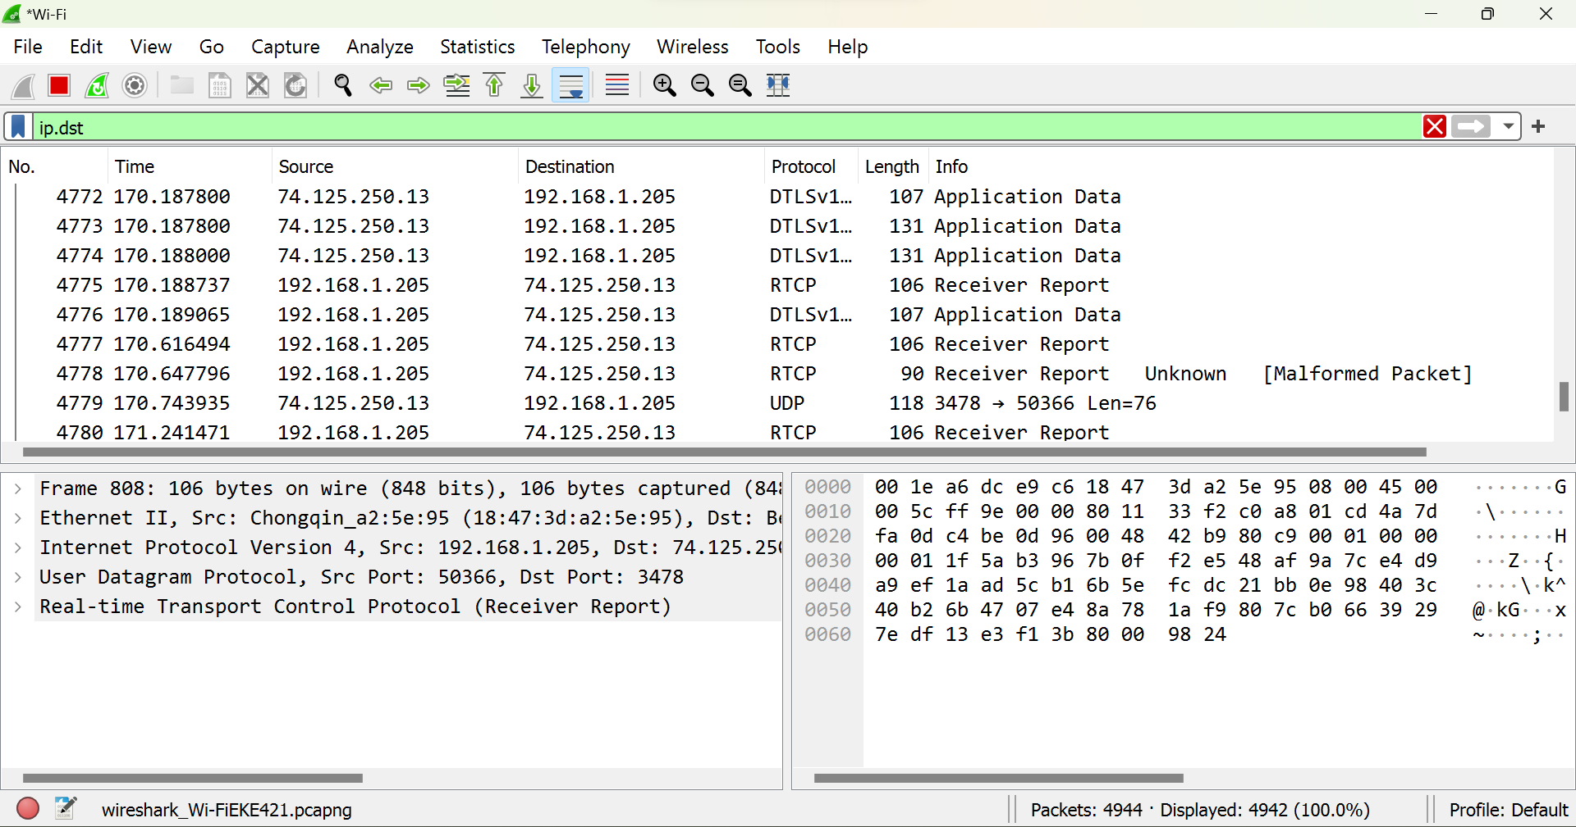

**Wireshark tcp filter applied:**

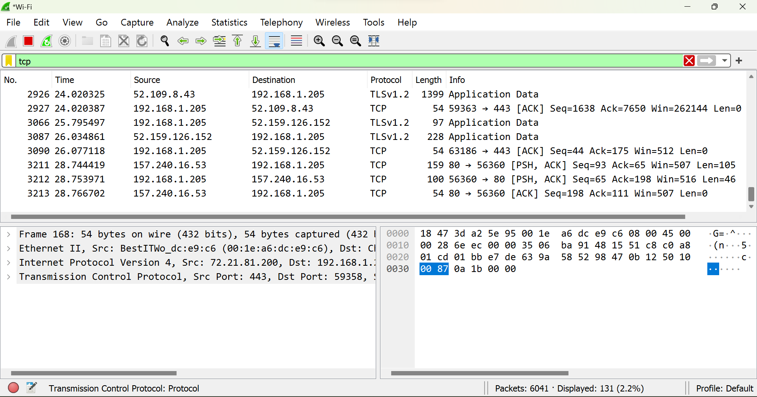

**Wireshark udp filter applied:**

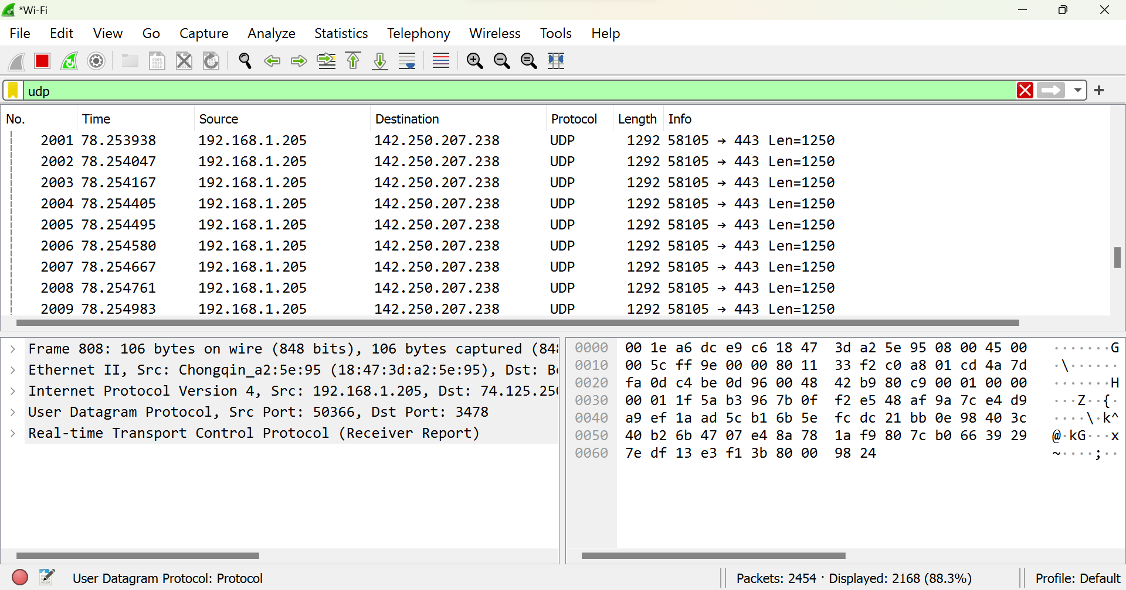

**Wireshark http filter applied:**

